
Please return the completed form to the reception of Fruške Residence.

The reservation is valid only in this format.

Date:

Full Name:

City:

Country:

E - mail:

Arrival Date:

Departure Date:

Hotel Fruške Residence 22.09-24.09.2027.

Bed & Breakfast:
– EUR 132.00 per night in a Standard family apartment (single occupancy)
– EUR 76.00 per person per night in a Standard family apartment (double occupancy)

Tourist tax: EUR 0.95 per person per night

Package includes:
- Check-in at 14:00, check-out at 11:00
- Accommodation based on selected service
- Water world at Mövenpick Resort & Spa Fruške Terme
- Sauna world at Mövenpick Resort & Spa Fruške Terme
- Garage parking

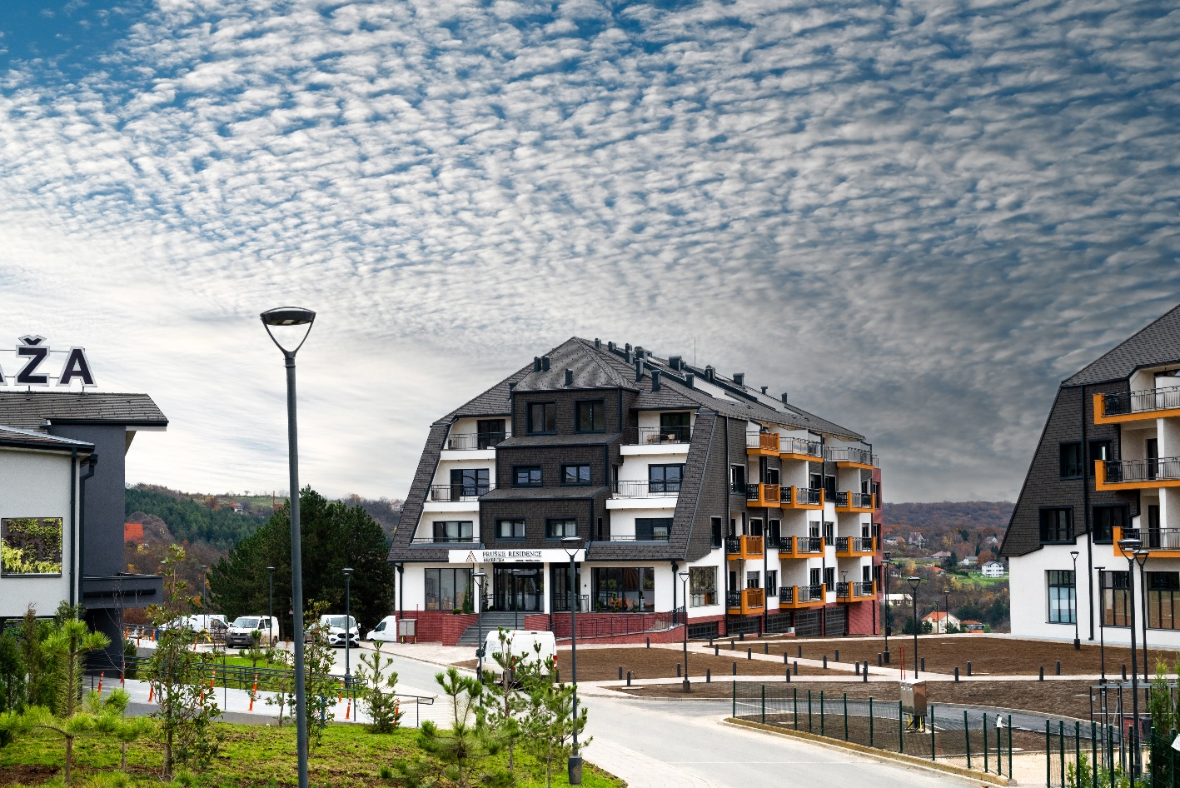

Accommodation type (subject to availability):
Please mark the desired option:
1. Standard family apartment (for one person)
2. Standard family apartment (for two persons)

A 100% advance payment is required to confirm the reservation.
If payment is to be made via a company account, company ID details must be provided.

Accommodation reservations can be made no later than 10.09.2027, subject to availability.
For reservations after this date, the hotel does not guarantee price or availability.

Cancellation policy: 14 days before arrival: 50% of the paid amount is retained, 7 days before arrival: 100% of the paid amount is retained.
We wish you a pleasant stay!

Reservation contact: info@frusketerme.com

Phone: 022/21-55-260
063/495-477

